**MOHSIN KHAN – SP20-BSE-067**

**RAILWAY RESERVATION SYSTEM**

**Book Ticket (USE CASE)**

**BRIEF**

This Use Case will begin when the passenger wants to register account. User will enter his details That include Email, Username, Contact Number, CNIC and Password and will click confirm.

The User has successfully registered to the system

**USE CASE DIAGRAM**

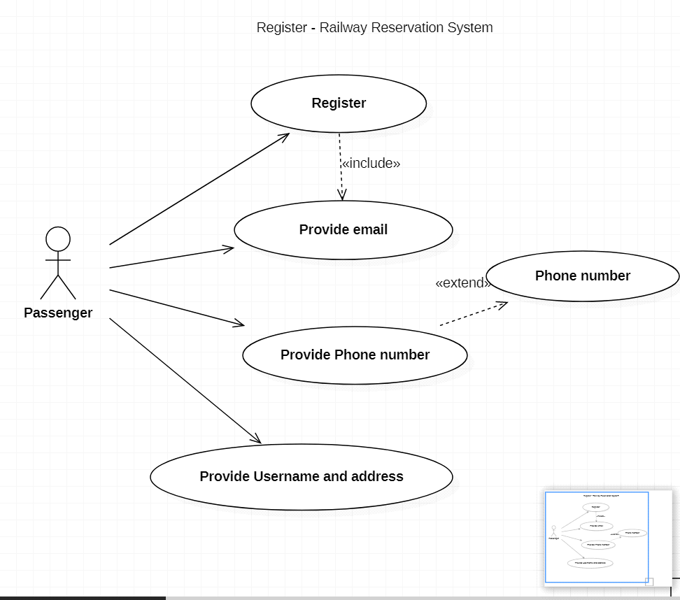

**FULLY DRESSED DIAGRAM**

|  |  |
| --- | --- |
| **USE CASES** | **COMMENT** |
| Use Case Name | Register |
| Scope | Railway Reservation System |
| Level | User Goal |
| Primary Actor | Passenger |
| Stockholders and Interests | Passenger: wants to register an account  Admin: wants the detail of the passenger |
| Preconditions | The user daetails must be correct. |
| Success Guarantee | The user will be allowed to use the application and can make reservation for the seats |
| Main Success Scenario | The user will provide details, like CNIC number, email,phone number and easy paisa or bank account number |
| Extensions | If the details are not correct the registration will be failed |
| Special Requirements | Reliability, Maintainability, and Usability |

**Domain Model**

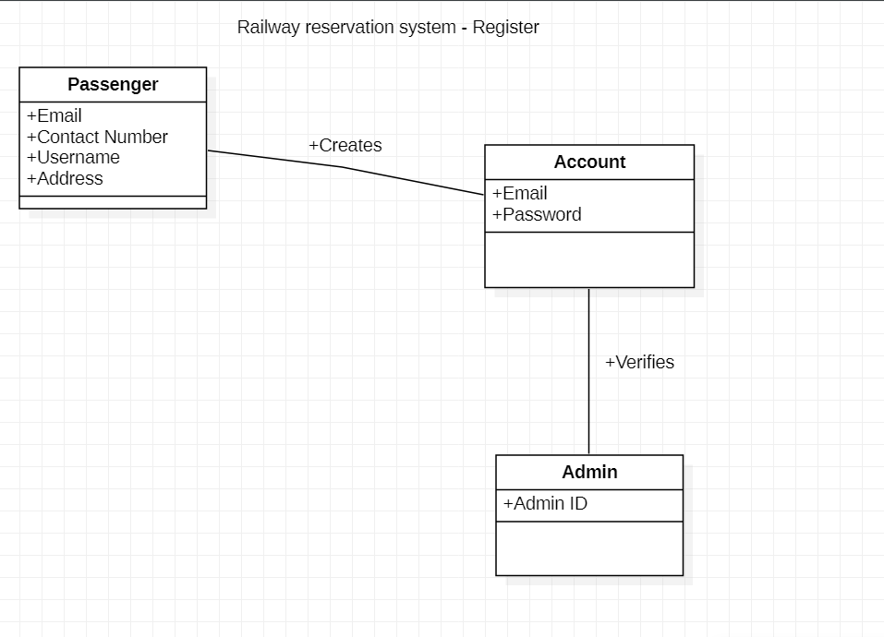

**System Sequential Diagram**

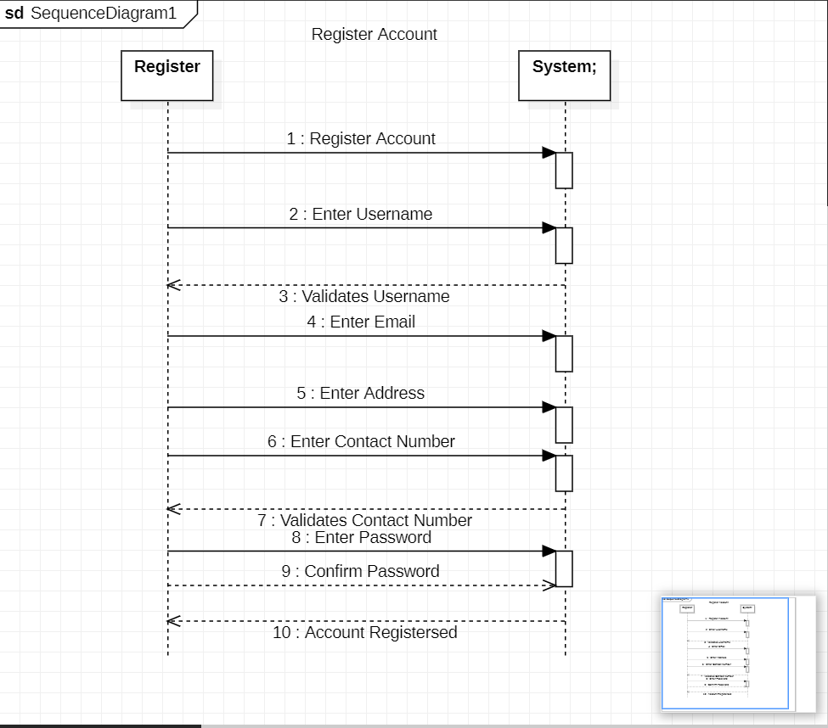

OPERATION CONTRACTS

**OPERATION –** Fill Form

**CROSS REFERENCE –** Register

**PRECONDITION –** the passenger must enter the system

**POSTCONDITION –** the registration form will be filled correctly, and passenger will be registered to the system